**INGENIERÍA DE SOFTWARE 2**

**Equipo: Nymax**

**Fecha de elaboración:** 28/08/2020

**Tema:** Acceptance testing

**Snapshots of the process**

Install Behave library

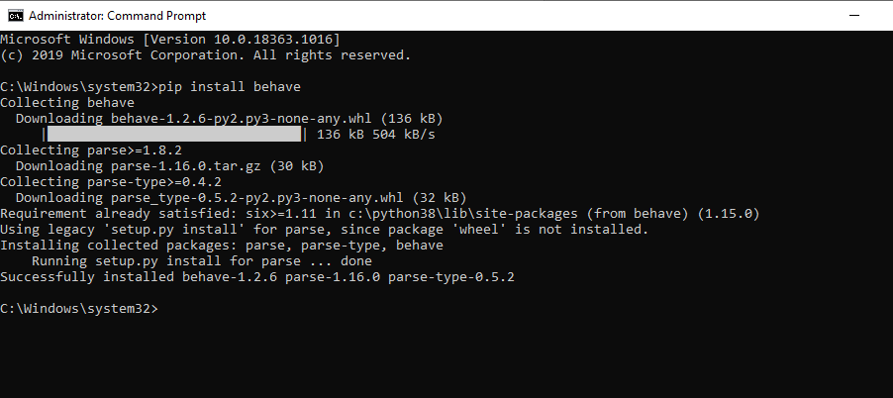

Clone repository

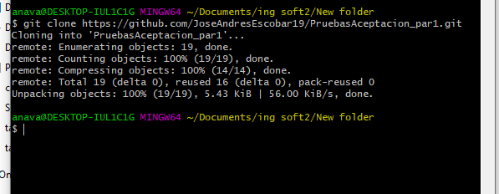

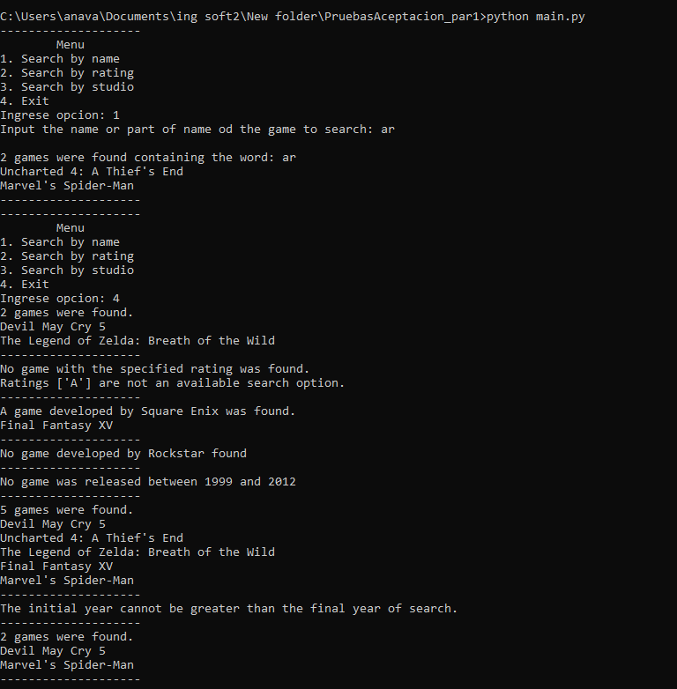

Verify the code has no errors.

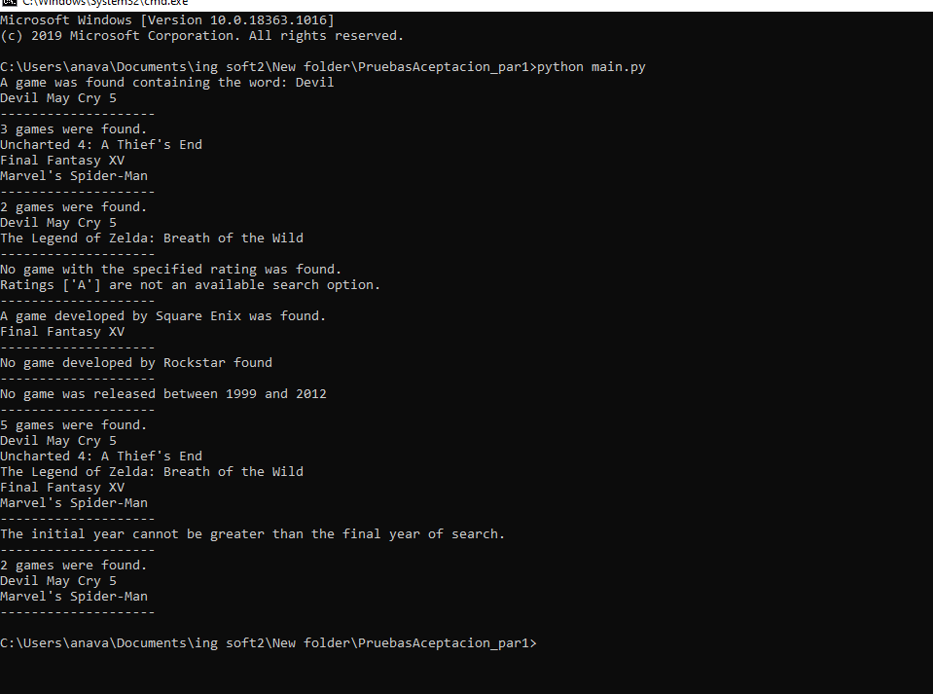 **Review examples and learn from them**

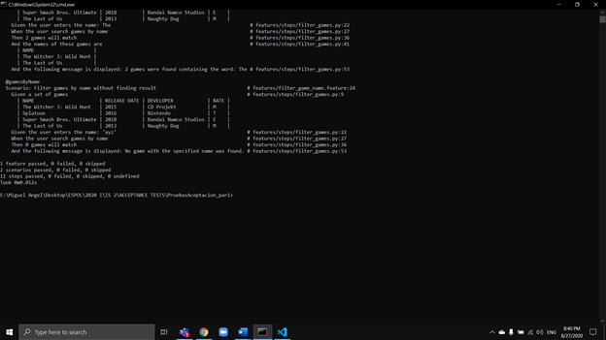

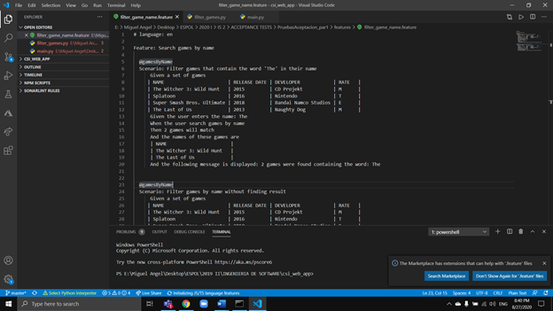

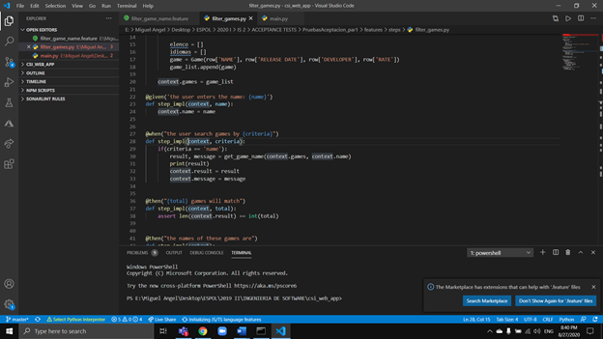

**Develop acceptance tests**

1) As a user I want to view a list of the games by rating, selecting one or more categories [E, T, M] to find games by type of audience.

i. [CA] GIVEN the user selects one or more ratings WHEN choosing the "search by ratings" option, THEN the name of all the games that correspond to these categories will be displayed.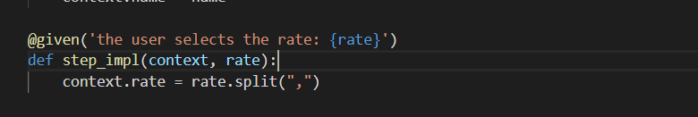

Given definition to get pre-condition with rate.

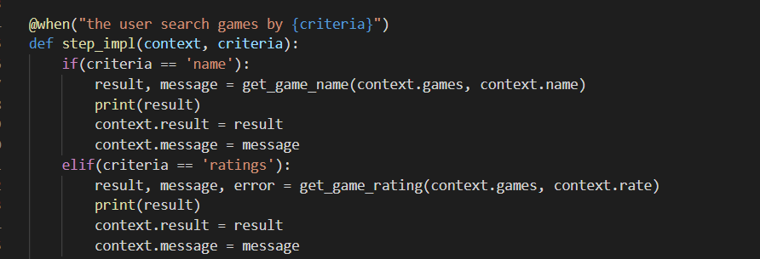

Adding rating criteria at when to identify when is looking for ratings.

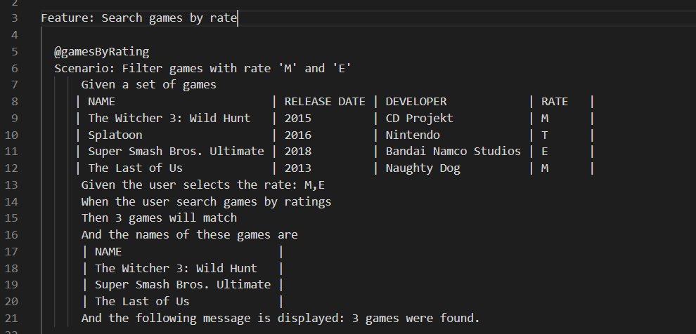

Defining first test with rate M and E.

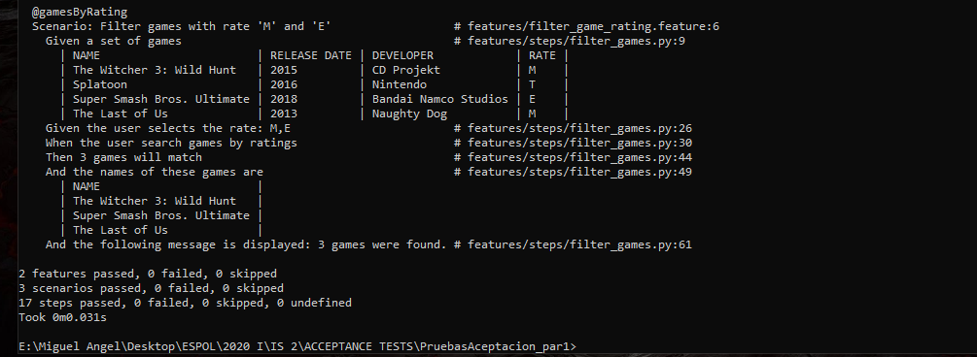

Behave command output with the first scenario.

ii. [CA] GIVEN the user selects one or more ratings WHEN choosing the "search by ratings" option, but there is no match with the list of games, THEN the following message will be displayed: No game with the specified rating was found.

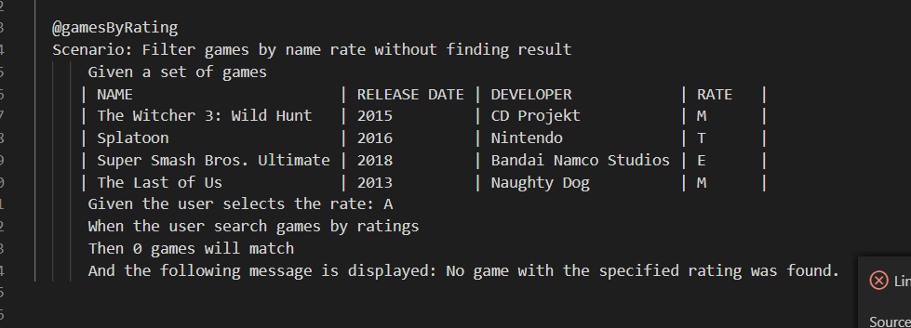

Defining the second test with no rate.

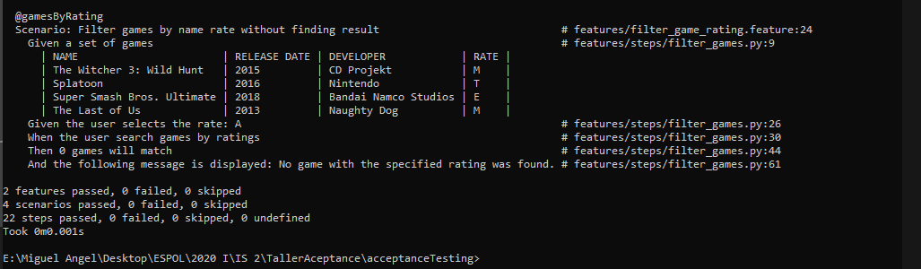

Behave command output with the second scenario.

1) As a user I want to get the list of games by manufacturer to find all the games that have been developed by a certain video game studio

i. [CA] GIVEN the user enters a studio WHEN they select the "search by studio" option, THEN the name of all the games that have been developed by that studio will be displayed.

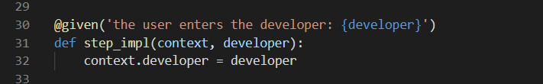

Given definition to get pre-condition with developer.

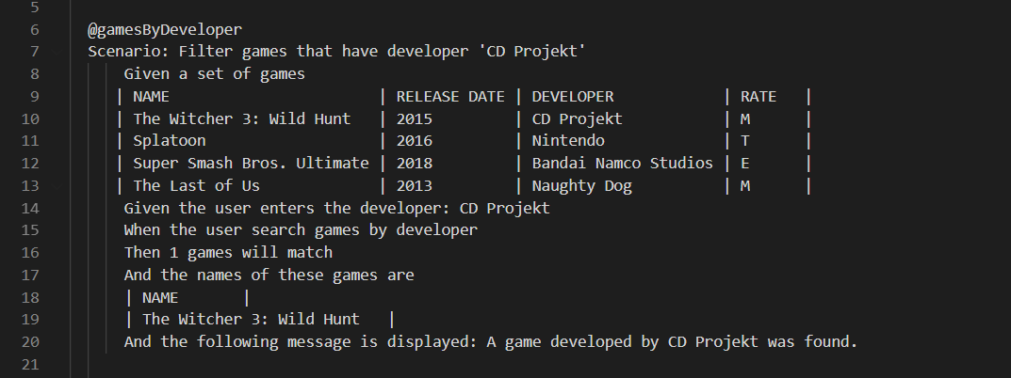

Defining the first test with no rate.

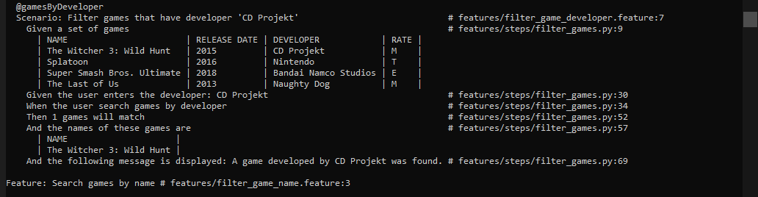

Behave command output with the first scenario.

ii. [CA] GIVEN the user enters a studio WHEN he selects the "search by studio" option, but there is no match with the list of games, THEN the following message will be displayed: No game developed by {studio} was found

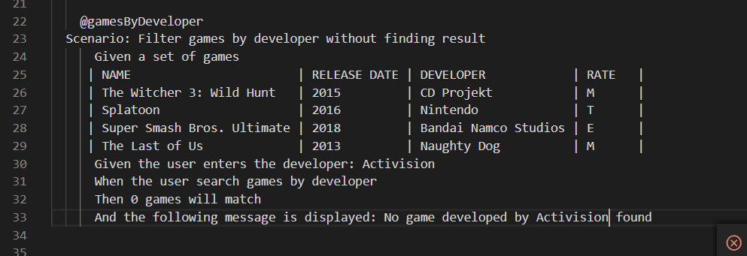

Defining the second test with no rate.

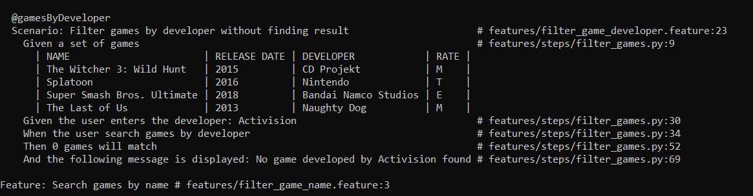

Behave command output with the second scenario.